65-year-old female presents to the Emergency Room with 90-minute history of chest pressure radiating to the left jaw.
History: Smoker 1 pack per day/ 20 years, hypertension & osteoarthritis. She has not seen a primary care provider in over 5 years.
Medications: None, she stopped taking medication for her blood pressure more than 5 years ago and does not check her blood pressure at home.
Vital Signs on presentation: Blood pressure 180/110, heart rate 100, Respiratory rate 24, Temperature 98.7 F, Pulse ox 95%, Pain scale 10/10
ECG Findings: ST Elevated MI

As the nurse you are triaging this patient in the ER and note that on ECG she is having a myocardial infarction. The cath lab team has been called in. However she is still having chest pain.
1. identify at least 2 pharmacological interventions you might anticipate as the nurse you will or could implement while this patient is waiting to go to the cath lab. You will need to provide rationale for why you chose those 2 medications. (6pt total, 1 for each medication and 2 for each rationale)
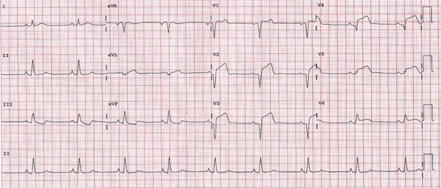

This patient went to the cath lab and had 2 stents placed in the left anterior descending artery. She is now back on your unit post-catheterization in stable condition and is not having any complications related to her heart attack. Her vital signs have improved:
Blood pressure 142/85, RR 16, Temp 98.7, Heart rate 72
Refer to the ST Elevated MI chapter
2. Explain which medications you would anticipate this patient would need to be on after presenting with ST elevated MI and having a cardiac intervention. Again explain why this patient would be on these particular medications(briefly explain the therapeutic indications for these medications) (HINT you should have at least 4)(points 0.5 for each medication, 1 pts for rationale) (total 6 points)
3. It is now 2 days later and this patient starts to complain of shortness of breath. Her echocardiogram shows reduced left ventricular function. with ejection fraction of 35%. On exam she has 2+ pitting edema in the lower extremities and rales in the lung bases. You review her weight and note she is up 7 pounds since her admission 2 days ago. Given her exam findings answer the following:
a. What would you expect is going on with this patient? In other words what would you anticipate her diagnosis to be? (1pt)
b. What would be the primary drug class you would use to treat this patients condition now? So in other words it is obvious she is fluid overloaded so what would you use to treat this problem and why? (2pts)

